How to set up the Smart Voice app to run on Android Studio
Android Studio version:
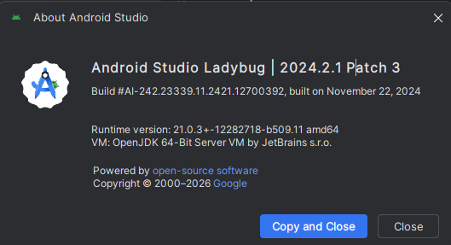
Under compileOptions in build.gradle app level:
- Set sourceCompatibility to VERSION_17
- Set targetCompatibility to VERSION_17
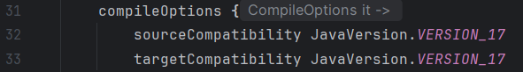
- Set jvmTarget to 17 under kotlinOptions
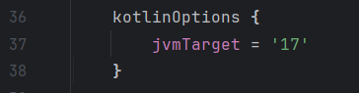

- Then go to Settings Build, Execution, Deployment Build Tools Gradle
- Then on Gradle JDK it should be jbr-17 JetBrains Runtime, then location should be on your device
